RISC-V Pipelined Processor Design

Farah Awadalla
Department of Computer Science
Nile University
Cairo, Egypt
F.Moustafa2306@nu.edu.eg
Mariam Hamada
Department of Computer Science Nile University
Cairo, Egypt
M.Hamada2399@nu.edu.eg
Shaza Hossam
Department of Computer Science Nile University
Cairo, Egypt
S.Hossam2328@nu.edu.eg
Taghreed Oyoun
Department of Computer Science
Nile University
Cairo, Egypt
T.Ghassan2378@nu.edu.eg

Dalia Nassar
Department of Computer Science
Nile University
Cairo, Egypt
D.Yaser2310@nu.edu.eg

Abstract—This report involves the design, implementation and simulation of a complete RISC-V Pipelined Processor using Verilog. Focuses on transitioning from a single-cycle Datapath to a five-stage pipelined architecture; Instruction Fetch (IF), Instruction Decode (ID), Execute (EX), Memory Access (MEM), and Write Back (WB) to increase instruction throughput. The design utilizes pipeline registers to isolate stages and implements hazard detection to handle data and control forwarding. The processor supports R-type, I-type arithmetic, Shift instructions, 64-bit Memory Access, and Branching.
Keywords—64-bit Memory Access; Branching; CPU; Five-stage Pipeline (IF, ID, EX, MEM, WB); I-type; RISC-V; R-type; Shift Instructions; Verilog

Introduction
Pipelining is a fundamental architectural technique used to enhance CPU performance by overlapping instruction execution, like an assembly line, by breaking instructions into five-stages: fetch, decode, execute, memory access, and write back and processing different instructions in different stages simultaneously, significantly increasing throughput by aiming for one instruction completed per clock cycle after the initial pipeline latency is overcome. It exploits instruction-level parallelism, but introduces challenges like hazards (data, control, structural) requiring solutions such as forwarding and stalling.[1]
The RISC-V instruction set architecture (ISA) is designed in a way that allows splitting every instruction execution into the same stages. All processor core instructions include a basic integer instruction set principles, this implementation supports 64-bit (doubleword) memory operations. This open-standard ISA follows Reduced Instruction Set Computing (RISC) principles and features no branch delay slots, supporting optional variable-length instruction extensions. As a 32-bit processor, all instructions are 32-bit long, using three operand registers (two source and one destination) [2] to facilitate efficient pipeline execution.
latency (pipeline) : The number of stages in a pipeline or the number of stages between two instructions during execution.

Datapath diagram

The architectural foundation of this processor is a five-stage pipeline. Each stage is separated by pipeline registers that hold the instruction state and control signals for subsequent cycles. The Datapath follows these five distinct stages:

Instruction Fetch (IF): The Program Counter (PC) provides the address to retrieve a 32-bit instruction from the Instruction Memory.

Instruction Decode (ID): The instruction is decoded by the Merged Control Unit, and the Register File is accessed to read the source operands. Simultaneously, the Immediate Generator extracts and sign-extends any necessary immediate values.

Execute (EX): The ALU performs the required arithmetic or logic operation or calculates the effective memory address for load/store instructions.

Memory Access (MEM): For memory instructions, the processor accesses Data Memory to perform a 64-bit Read (ld) or Write (sd) operation.

Write Back (WB): The result, originating from either the ALU or Data Memory, is written back into the destination register within the Register File.

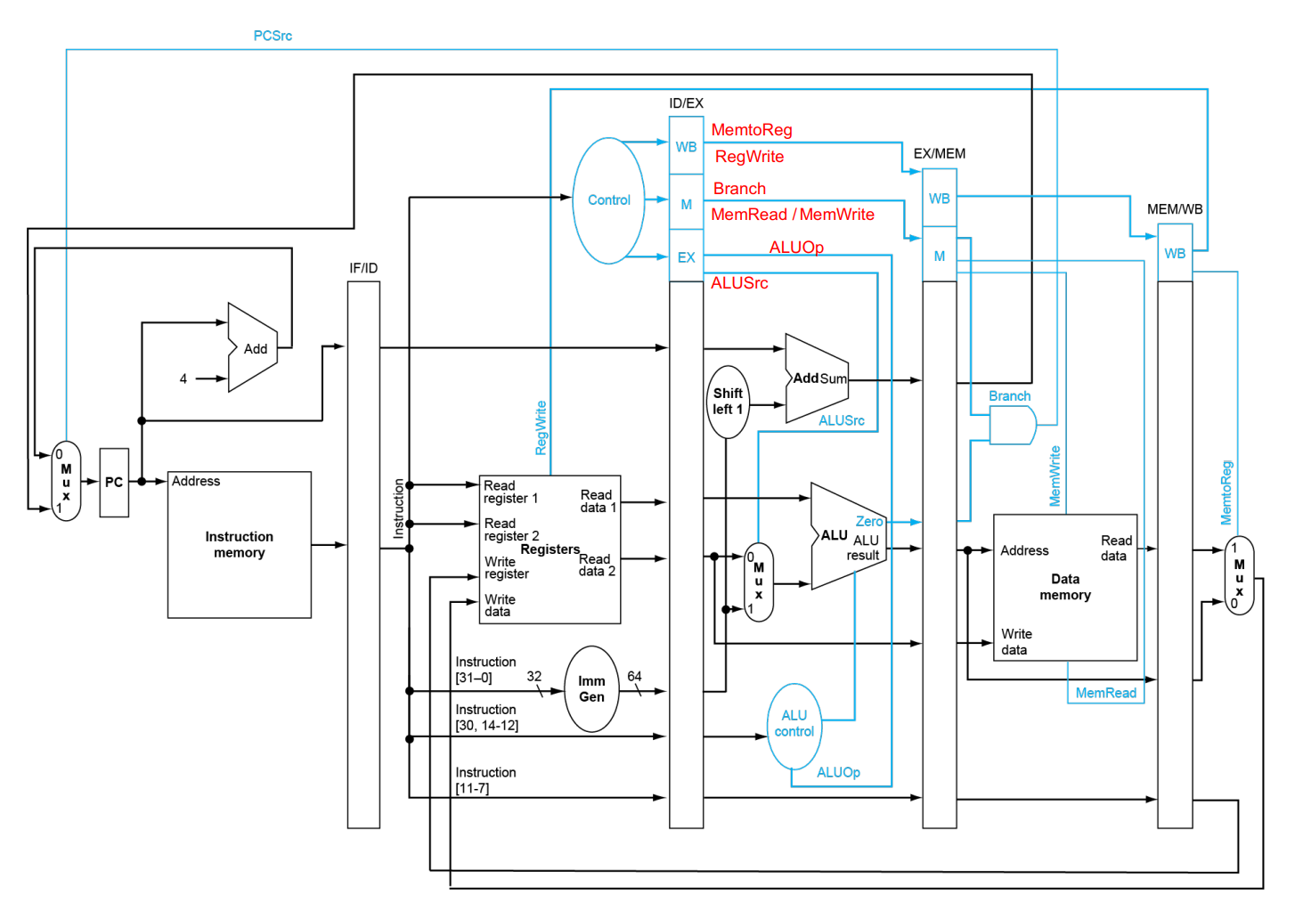

Figure 1

Design Methodology
The development of the pipelined RISC-V processor followed a modular hardware design methodology. The process began with the independent implementation and verification of core hardware modules to ensure localized correctness before system-wide integration. Each module was designed using Verilog and verified with a dedicated testbench to confirm its logic against the RISC-V specifications. Following individual verification, these components were integrated into a five-stage Datapath, utilizing pipeline registers to isolate execution stages and increase instruction throughput.

Explanation of modules
The Integrated modules :

ALU & Arithmetic Logic Design (ALU)
The Arithmetic Logic Unit (ALU) is the computational core of the processor. It is responsible for executing all R-type and I-type arithmetic and logic operations, including ADD, SUB, AND, OR, XOR, and bitwise shifts.

Control Encoding:
A 4-bit control signal (ALUCtl) is used to select the required operation. The encoding is derived from RISC-V funct3 and funct7 fields via the control unit.

ALUCtl | Operation
0000 | AND
0001 | OR
0010 | ADD
0011 | XOR
0100 | SLL
0101 | SRL
0110 | SUB

Verilog Implementation:
The ALU is implemented as a combinational module using an always @(*) block and a case statement. The Zero flag is asserted when the ALU result equals zero, which is required for branch instructions such as BEQ.

Console Results:

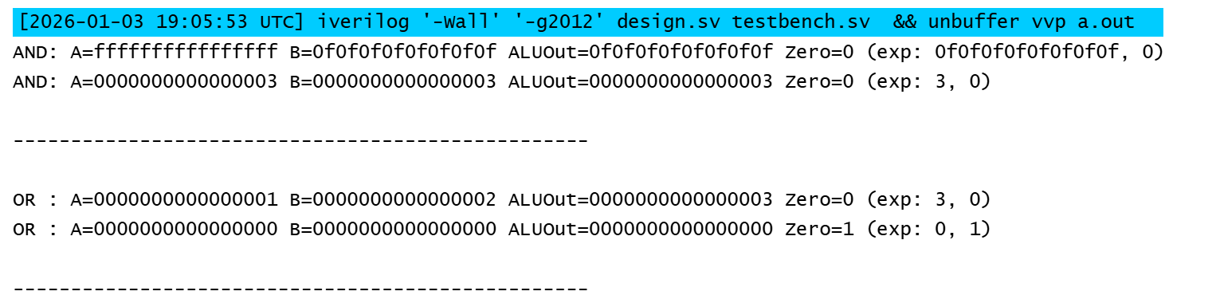

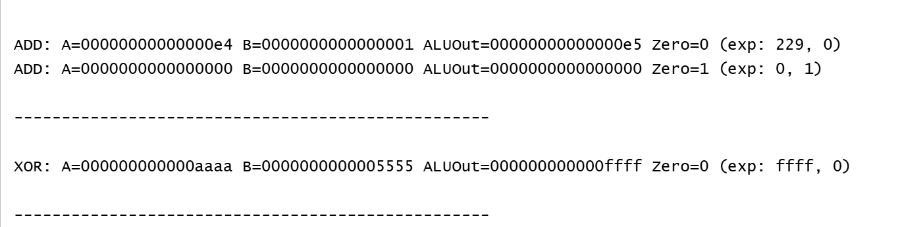

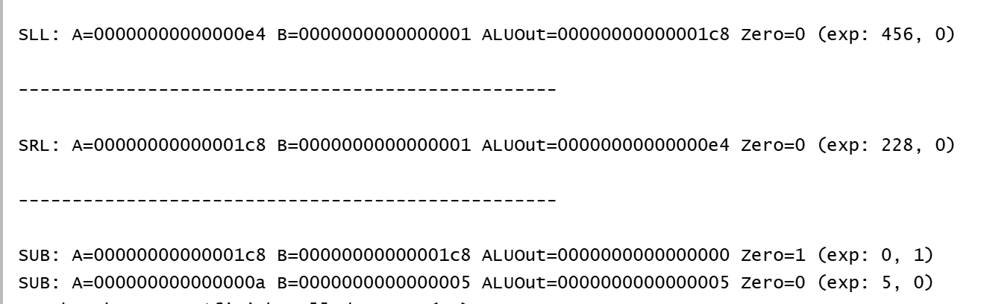
Figure 2

Waveform Result:
SUB Operation only

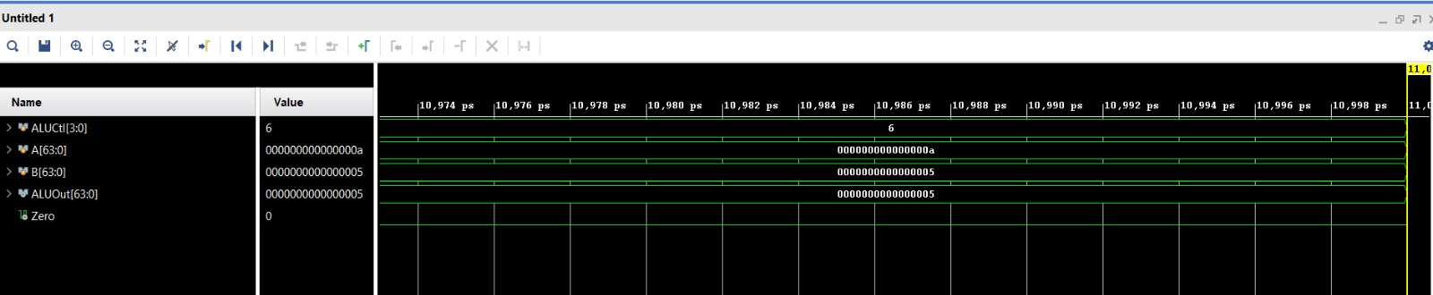

Figure 3

Control Unit
The Control Unit is the decision-making hub of the processor, responsible for decoding the instruction opcode and generating the control signals required to coordinate the Datapath. While the single-cycle version applies signals all at once, this pipelined implementation utilizes Pipeline Registers to propagate signals stage-by-stage through the five stages: IF, ID, EX, MEM, and WB.

instruction | Reg  Write | Mem  Read | Mem  Write | ALU  Src | Mem  To Register | branch
Add/sub | 1 | 0 | 0 | 0 | 0 | 0
ADDI | 1 | 0 | 0 | 1 | 0 | 0
LD | 1 | 1 | 0 | 1 | 1 | 0
SD | 0 | 0 | 1 | 1 | 0 | 0
BEQ | 0 | 0 | 0 | 0 | 0 | 1
Waveform Result:
Figure 4
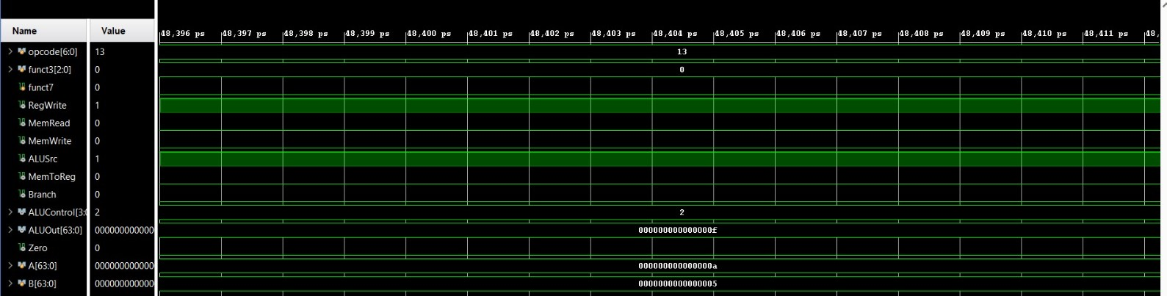

Register File & Immediate Generator
The Register File and Immediate Generator execute during the Instruction Decode stage of the RISC-V processor. The tasks of these modules include providing operands as well as immediate values needed for executing operations.
The Register File, as per the RISC-V RV64 specification, is composed of 32 general-purpose registers of size 64 bits, in which the register x0 is hardwired to be zero.The Register File has two asynchronous read ports to fetch the source registers and one synchronous write port that writes the destination register in the WB stage upon the activation of the RegWrite signal.
The Immediate Generator extracts the sign-extend version of the immediate values from the instruction depending on the format of the instructions. It does the extraction for the I-Type immediate values in the case of R-Type instructions, for the S-Type immediate values in the case of S-Type instructions, and for the B-Type immediate values in the case of B-Type instructions. All the immediate values are sign-extended to 64
bits to match the processor datapath.

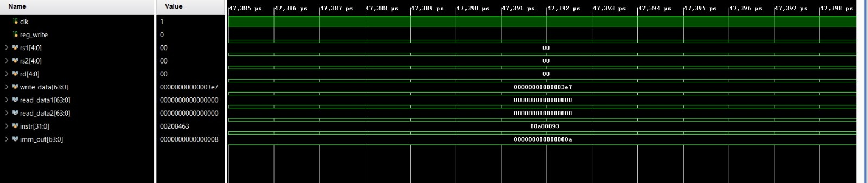

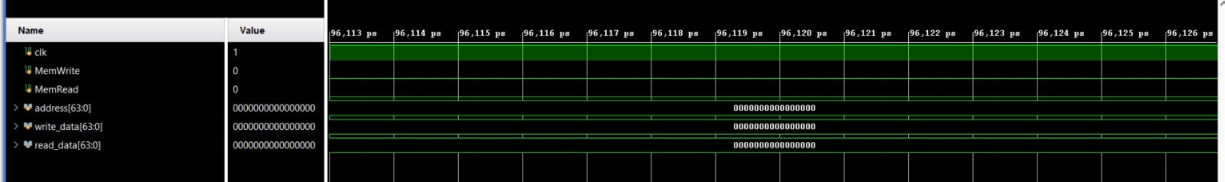
Program Counter, Branch Logic & PC Update
single-cycle and pipelined RISC-V processors. The PC controls instruction sequencing by selecting between sequential execution and branch target addresses.
In the single-cycle design, the PC is updated every clock cycle using either PC + 4 or a branch target address computed as the current PC plus a sign-extended immediate offset. The branch decision is resolved within the same cycle using the Branch control signal and the ALU Zero flag, with no support for stalls.
In the five-stage pipelined implementation, branch instructions are decoded in the ID stage, while branch target calculation and decision making occur in the EX stage. As a result, branch information arrives later in the pipeline, requiring the PC logic to prioritize registered EX-stage branch signals. A pc_write control signal was added to support pipeline stalls during hazards, allowing the PC to be frozen when necessary.
Verification using a standalone testbench confirmed correct sequential execution, forward and backward branching, and proper PC stalling behavior.
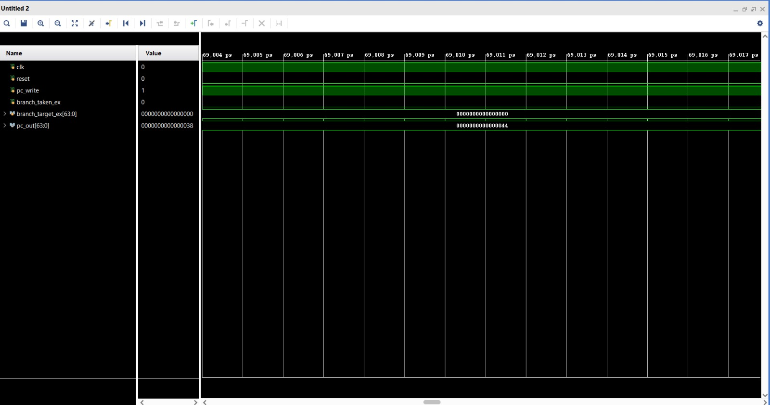
Figure 5

Instruction Memory, Data Memory & Top-Level Integration
individual components into a cohesive five-stage
pipelined processor. This integration ensures that both data and control signal propagate correctly through the pipeline registers.

Memory Modules Implementation
The Instruction Memory was implemented as a read-only module initialized using the $readme system task to load RISC-V machine code. It outputs a 32-bit instruction based on the current Program Counter value. The Data Memory was designed as a 64-bit synchronous memory module supporting

load (ld) and store (sd) operations, and it interfaces directly with the Memory (MEM) stage to handle persistent data storage.

Top-Level Pipelined Integration
The purpose of this module is to implement and integrate a five-stage pipelined RISC-V processor that executes 64-bit RISC-V instructions correctly and efficiently. The processor is designed to follow the classic pipeline stages: Instruction Fetch (IF), Instruction Decode (ID), Execute (EX), Memory Access (MEM), and Write-Back (WB).

Integration Challenges (Hazard Handling)
During integration, challenges arising from instruction overlap were addressed. Data hazards were handled by detecting cases where an instruction depends on a result that has not yet been written back to the Register File. Control hazards were managed by integrating branch logic within the pipeline to ensure correct target address calculation and proper instruction fetching following branch (beq) operations.

Results and waveforms

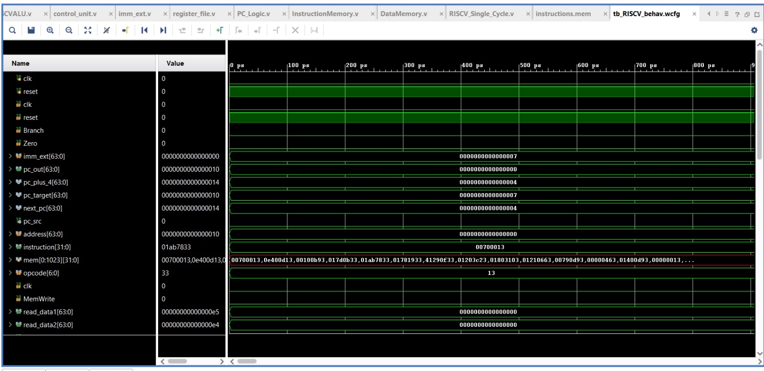

Conclusion
This project successfully demonstrated the design, implementation, and verification of a high-performance, five-stage pipelined RISC-V processor using Verilog. By transitioning from a single-cycle Datapath to a pipelined architecture, the design effectively maximized instruction throughput by overlapping the fetch, decode, execute, memory access, and write-back stages. The integration of a merged Control Unit and a dedicated Hazard Detection system ensured that the processor could handle complex data and control dependencies while supporting a robust instruction set, including 64-bit doubleword memory operations and conditional branching.

References

- J. Hennessy and D. Patterson, “Computer Organization and Design RISC-V Edition”, Morgan Kaufmann, 2020.
- 9 th MDSRIC, 16-17 Oct 2024 Wah Cantt/Pakistan

Github-Repository:https://github.com/maryaam5/Architecture

